Agriculture's Role in Climate Change

Project 1

Group 5

Nicole Pipkins

Yushan Sarah Gao

Roberto De La Torre

Sylvester Vredenburg

Sam Jebreen

**Introduction**

Climate change occurs when different greenhouse gases collect in the atmosphere. These gases will absorb sunlight and solar radiation that have bounced off the earth’s surface. The greenhouse gas (GHG) emissions humans generate are the leading cause of the earth’s rapidly changing climate. Concentrations of carbon dioxide, methane, and nitrous oxides are generated from the agricultural form of manufacturing and transportation. Animal agriculture is a significant source of other greenhouse gases. Animals like cattle produce methane, which is a greenhouse gas more potent than carbon dioxide.

This project seeks to understand the complex relationship between agriculture and climate change. Agricultural production both contributes to climate change in the form of manufacturing and transportation, while also being directly affected by climate change’s meteorological consequences. We examined available global agricultural production and emission data, then compared this to the weather patterns and crop production data on the United States.

**Greenhouse Gases by Country**

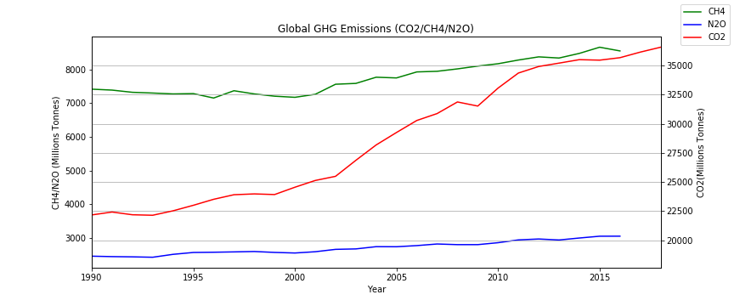The first graph represents all greenhouse gases that trap heat in the atmosphere. Carbon Dioxide (CO2) is the main contributor to climate change and accounts for 81% from GHG emissions, especially from the burning of fossil fuels. Worldwide data has shown carbon dioxide with a higher incline trend overtime compared to the rest of GHG gasses making it a top contributor towards climate change. Methane (CH4) is produced mainly when vegetation is digested, burned, or rotted making it more related to the agricultural section. Methane accounts for 10% of all greenhouse emissions, but considered 30 times more potent as a heat trap contributing towards higher temperatures. Nitrous Oxide (N2O)is released mainly by chemical fertilizers, and its potential towards global warming is higher than CO2. Nitrous oxide contributes about 7% of GHG emissions.

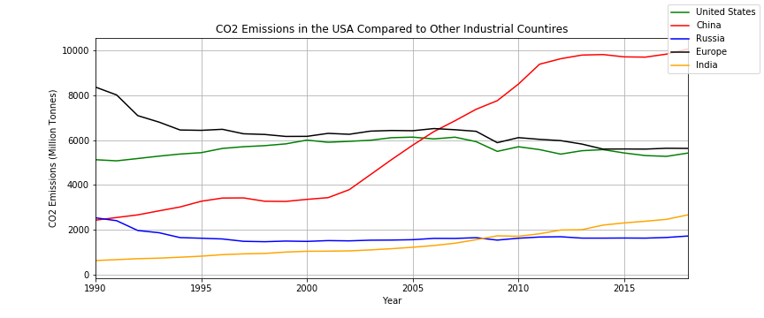The second graph compares the United States as a CO2 emission contributor compared to top GHG emission contributors worldwide. The United States took the lead until 2006 when China took over. Currently the US contributes about 14% of CO2 emissions worldwide based on the data shown. The US is almost on the same level of CO2 contribution to all countries within the european region after china. This puts the United states as a top contributor to climate change emitting ~5 billion metric ton of CO2 on average. Top contributors can have a major impact on 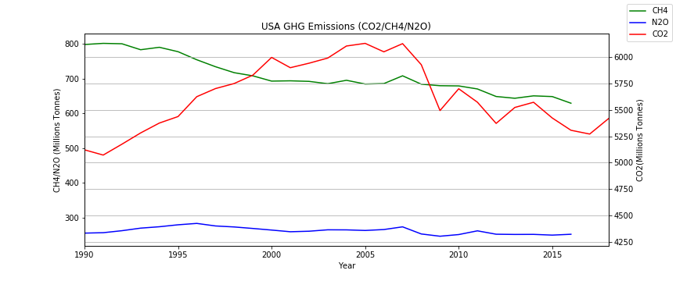climate change worldwide and locally.

GHG emissions have shown higher trends in the US until 2006 when the US began investing in cleaner energy to reduce GHG emissions. Since 1990, GHG emissions have increased ~5% based on the data shown if we look at the overall change. The change is different from year to year and is affected by the changes of economy, fuel price, and other factors. This can explain the change in climate change from year to year. Climate change can affect field crops making it a vice versa relationships, where producing field crops causes GHG emissions leading to climate change, and in it’s role can lead to reducing field crops production.

**Greenhouse Gases by Economic Sector**

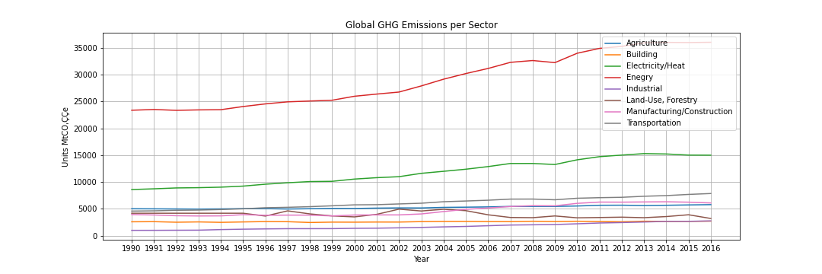

The first graph represents all greenhouse gases emitted, on a global scale, per economic sector. It is clear to see that the Energy sector surpasses all the other sectors pretty substantially. This is explainable because this sector has activities like drilling for oil or mining for coal. The four major countries that contribute over two-thirds to the global energy emissions are: United States, European Union, China, and India.

There is a small dip in both the Energy sector and the Electricity/Heat sector, around 2009. And then, as these lines gradually go back up, they begin to level out. This can be explained by the trend for some to want “to-go-green” and help the plant, as global warming has been a more constant current event. It's interesting to see how the Transportation sector and the Manufacturing/Construction sector have surpassed the Agriculture sector in later years. This, again, can be generally understood by the change of times and the way humans interact within the world.

**The Agricultural Sector and Greenhouse Gases**

My next two charts look inside the Agriculture sector specifically and determine which countries, and which activities, contribute the most to global warming. It's important to mention that the Agriculture sector only holds two main Greenhouse Gas emissions, known as nitrous oxide and methane. The carbon monoxide emissions related to farming come from the use of the equipment on the farm, and these emissions are stored within the Land-Use and Forestry sector.

Nitrous Oxide

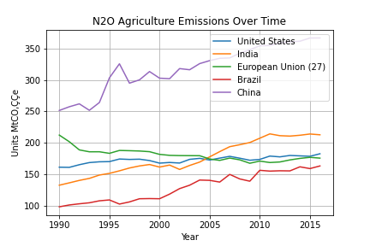

Agriculture sector’s first gas is N2O, or nitrous oxide. This gas is the highest emitting gas within the Agriculture sector. Activities from the Agriculture sector that contribute to N2O emissions pertain to management practices for the soil, examples include uses of different fertilizer or irrigation practices. Nitrous oxide is important to global warming because it is up to 300 times more effective in trapping in heat than carbon dioxide. The United States has remained in 4th place for emitting N2O, within the Agriculture sector, for over a decade. The more intriguing numbers are for China, where their N2O Agriculture emissions exceed all other top producing countries and these emissions have been on a constant rise.

Methane

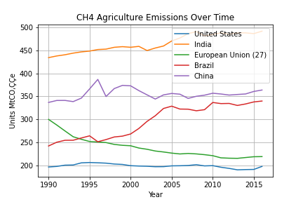

Agriculture sector’s second gas is CH4, or known as Methane. CH4 emissions account for just over a third of the total emissions levels within this sector. Activities from the Agriculture sector that contribute to CH4 emissions are related to livestock digestion and burning of crops. Methane is important to global warming because it is a very potent gas, meaning that it will actually trap in heat that was intended to leave the atmosphere. The United States emissions towards CH4, within the Agriculture sector, have remained low and constant compared to the other top producing countries.

**Global Meat Production**

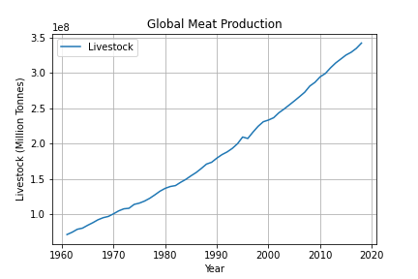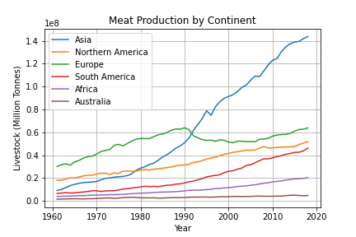

Meat products are a major food group in today’s diet. Poultry, pork, beef, game, and lamb all provide essential nutrients, minerals, and vitamins. Due to the growing population, the demand for meat products is also increasing. It has quadrupled over the past 50 years. Europe was the dominant meat producer but around the 1900's Asia started to increase production rapidly. Today, Asia is the largest meat producer, producing about 140 million tonnes each year. Which is almost half of total global meat production. North America used to be second in meat production right below Europe and now it is in third place. The graphs above show global meat production by continent, measured in tonnes.

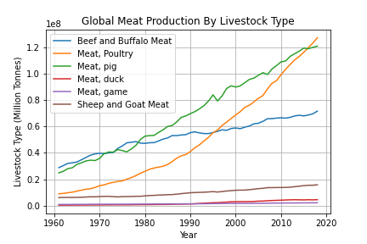 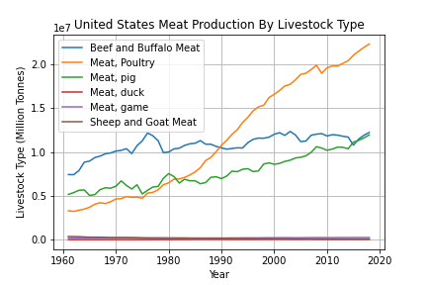

The graphs above show the global meat production by livestock type, poultry, pork, beef and buffalo, game, duck, wild game, sheep and goat. In the 1960's the dominant meat products were beef and pork. Around 1995, poultry started increasing rapidly due to the growing population and the change of diets. Poultry consumption is more popular now because this industry is one of the most successful sectors in agriculture around the world. It is successful due to the efficient structure, its low production costs relative to other meats. The same applies to the United States, poultry is the largest segment of the United States agriculture. The increasing population it is driving up the meat production has large environmental impacts, increasing greenhouse gases emissions, freshwater use, effluent waste, and land consumption.

**Effect of Climate change on weather patterns in the United States**

Using the Azavea Climate API, we examined weather data from a sample of 100 cities in the United States to create a visualization of the trend in extreme heat and precipitation events in the time period between 1950 and 2005 (the total time window of historical data available). After averaging the data from all 100 cities, the resulting time chart showed a dramatic increase in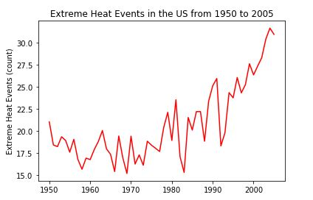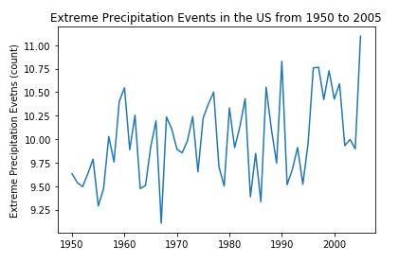

Heat events between 1980 and 2005, and a more gradual upward trend in extreme rain events across the entire time period. The graph of global emissions data lines up well with the data for heat events and, to a lesser extent, rain events. 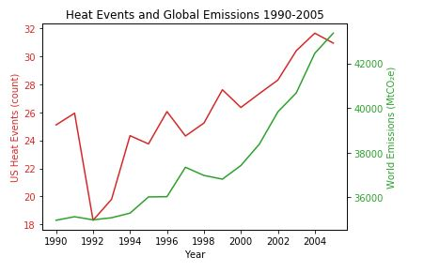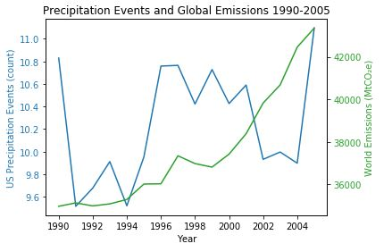

**How does climate change over time affect crops yield within the Midwest of the United States?**

**Weather effects on Iowa corn and soybean**

**Methodology**

To determine the weather effects on agricultural crops in the Iowa state, weather json files were obtained from the National Oceanic and Atmospheric Administration (NOAA) “Climate at a Glance” time series (ncdc.noaa.gov/cag/global/time-series). Nine different JSON files were called for specific months (June – August) related to the growth and harvesting of corn and soybean. Yield data from corn and soybean were downloaded as csv files from the Department of Agriculture (USDA) Quickstats (<https://quickstats.nass.usda.gov/>) after filtering the data for specific crops and parameters of interest on the USDA website. Data were analyzed using python.

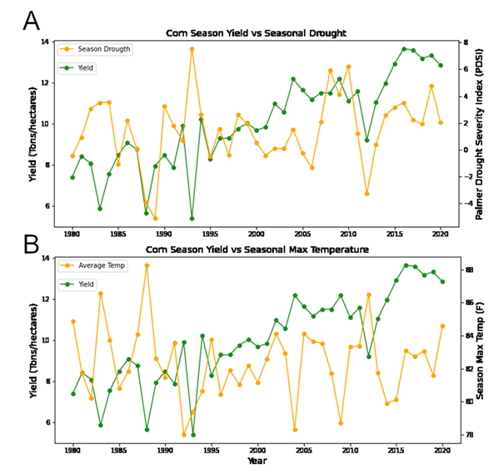

Figure 1: Corn season yield compared to seasonal drought severity and max temperature.

**Results and Discussion**

The state of Iowa was selected for this analysis as is one of the largest producers of crops, especially important crops such as corn and soybean. Moreover, weather in Iowa is homogenous throughout the whole state making the analysis between crop yield and weather easier in comparison with states with different climates. As seen in figure 1(A-B) extreme weather or unusual climate events (1980 - 2020) caused significant corn yield reduction in some years. The decrease in yield was related to extreme drought events (Palmer Drought Severity Index (PDSI) < 0) as seen in 1988 and 2012 or extreme precipitation (PSDI > 6) as revealed in 1993. A decrease in yield in 1983 correlates with extreme temperature as observed in figure 1B. Extreme temperature events also matched with the unusual dry seasons. Similar trend was observed for soybean (Figure 2 A-B) showing that both agricultural crops suffered yield losses due to high temperature, drier conditions, and flooding. 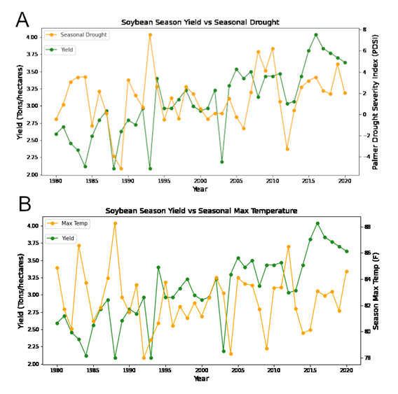

Figure 2: Soybean Corn season yield compared to seasonal drought severity and max temperature

The change in corn yield from year to year was compared to the changes in PSDI that occurred during corn season. As seen in figure 3A most years with below-average yields (< 0) significantly match with seasons that were drier than normal (figure 3B). There is a high relationship between yield reduction and dry conditions during the Iowa crop season.

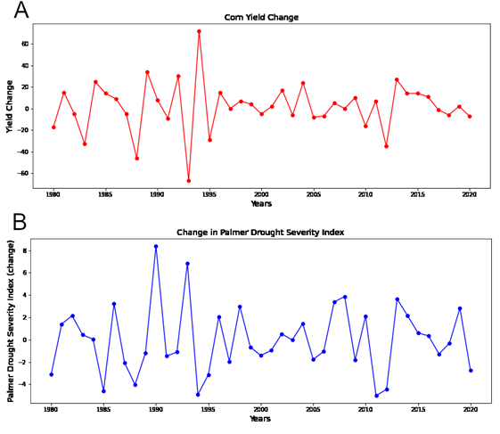

Figure 3: Changes in corn yield and drought severity during crop season from 1980 to 2020.

To determine if corn yield losses due to unusual weather events are significantly different to the average season yield, data from 1945 to 2020 was analyzed and compared to normal average yield for the season. Yield values that were below the season average and related to extreme weather events were collected and compared to normal average yield. The data were normalized (normalized yield) to their respective period as normal average yield from previous decades are different to today crop production due to population growth. Figure 4 shows a significant decrease (p-value = 5.96 e-12) in yield of 26% when comparing weather affected corn crops to normal (healthy) crop yield.

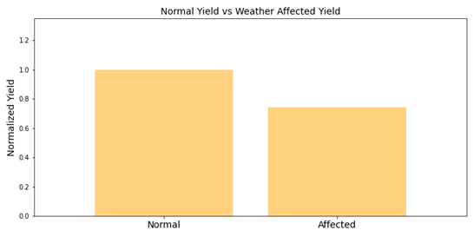

Figure 4: Normalized yield of normal average corn yield compared to weather affected corn yield

**Conclusion**

According to our study corn and soybean yield were affected by unusual weather events when PDSI were below 0 (dry) or higher than 6 (high precipitation). Extreme heat also affected crop yield when the temperature was higher than 85 F. Changes in corn yield were related to drier conditions. Moreover, unusual weather events decreased corn yield by 26% when compared to normal average yield. High CO2 is well known to boost crop yields by increasing rate in photosynthesis and reducing water losses through transpiration. Control field studies and global cross modeling performed by Daryng et al. (1) found that corn and soybean would experience severe reduction in yield due to high temperature and drier conditions induced by CO2 concentrations. However, some crops such as soybean could thrive at higher concentration of CO2 due to an increase in photosynthesis and water productivity, partially offsetting the impact of climate changes. Nevertheless, corn would suffer yield losses with higher concentration of CO2 due in large part to the already efficiency of corn in using CO2 for photosynthesis. Finally, if climate change continues these events of extreme weather might occur more often and adversely affect crop production in the USA.

**References**

1. Delphine Deryng, Joshua Elliot, Cynthia Rosenzweig. Regional disparities in the beneficial effects of rising CO2 concentration on crops water productivity. Nature Climate Change 2016, 6, 786-790.